CAT

BURGLAR

(Thief in the Night)

Game Design

Document

Game Dev Sim Team

**Table of Contents**

**Product Overview**

Single Line Pitch

Elevator Pitch

Game Pillars / Core Experiences

Platform and Genre

Influences

Target Audience

SWOT Analysis

Competitor Analysis

**Gameplay Details**

Core Gameplay Summary

Goal

Objectives

Conflict

Mechanics

Overview of Camera and Controls

Gameplay Loops

Economy

**Content Plans**

Levels

Enemies & NPC’s

Items to steal

Items Modular Rooms

Items (other)

Unlock/Awards

Visual FX

Sound FX

**Schedule**

Art Assets

Programming

**Product Overview**

**Basic Pitch Line / Single Line Pitch**

Stealth game where the player is a cat burglar attempting to steal from people’s homes without waking them up.

**Elevator Pitch**

Cat Burglar is a stealth game where the player must sneak around a house at night and search through the resident’s belongings looking for valuable items to steal. The challenge of the game lies in the player’s ability to steal items without alerting the residents of the house to their presence. The player accumulates score by stealing items. Each item has a different value attached to it, and the value of the items are displayed in dollars. The player will have to sneak around the house, trying to keep the noise they make to a minimum. As the player progresses and their score increases they will create more noise as they move, which will be indicated by a proximity ring around the player letting them know anyone within that ring may detect them.

**Game Pillars / Core Experiences**

Stealth

Skulk about in other people’s homes without being detected ~~or triggering traps~~.

Silent Intruder

Attempt to keep noise to a minimum, to avoid alerting the residents of the player’s presence.

Risk Versus Reward

The most valuable items to steal will be in the hardest to access locations.

Increased Difficulty

As the player collects more items, the chance of them being detected by the residents, will be increased.

Hasty Thief

It’s a race against time to steal as much loot as you can before the sun comes up.

**Platform & Genre**

Cat Burglar will be developed and released for PC, with the potential for it to be ported to mobile devices at a later date. Cat Burglar is a stealth game, that has its core gameplay mechanics based around strategy.

**Influences**

Hitman – Video game

Release Date: March 2016

Developer: IO Interactive

Genre: Stealth

Hitman is a long running video game series where the player takes the role a Hitman and is tasked with completing assassinations of various targets. The player is required to rely on stealth in order to locate and execute the targets.

The heavy stealth elements at the core of the Hitman games are what make it both challenging and fun, they are a clear influence on Cat burglar because they are necessary for the player to complete the game most effectively.

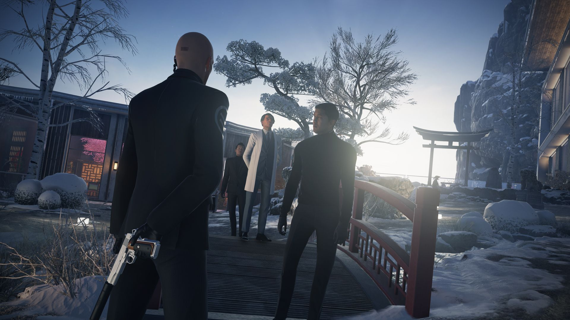

Tetris – Video game

Release Date: June 1984

Developer: Alexey Pajitnov

Genre: Puzzle

Tetris is well known and played video game due to its simple gameplay and ease of learning. The reason people continue to play it is because of its increasing difficulty level, the phrase easy to learn yet difficult to master is a very appropriate description of Tetris.

The simple mechanics of Tetris with its easy to learn yet hard to master gameplay make it a large influence on Cat Burglar as they both feature easy to learn gameplay with simple and minimal controls yet have an increasing difficulty which allows for people to have short intense gameplay sessions spread over a sustained period of time. This allows the player to control their level of involvement in the game.

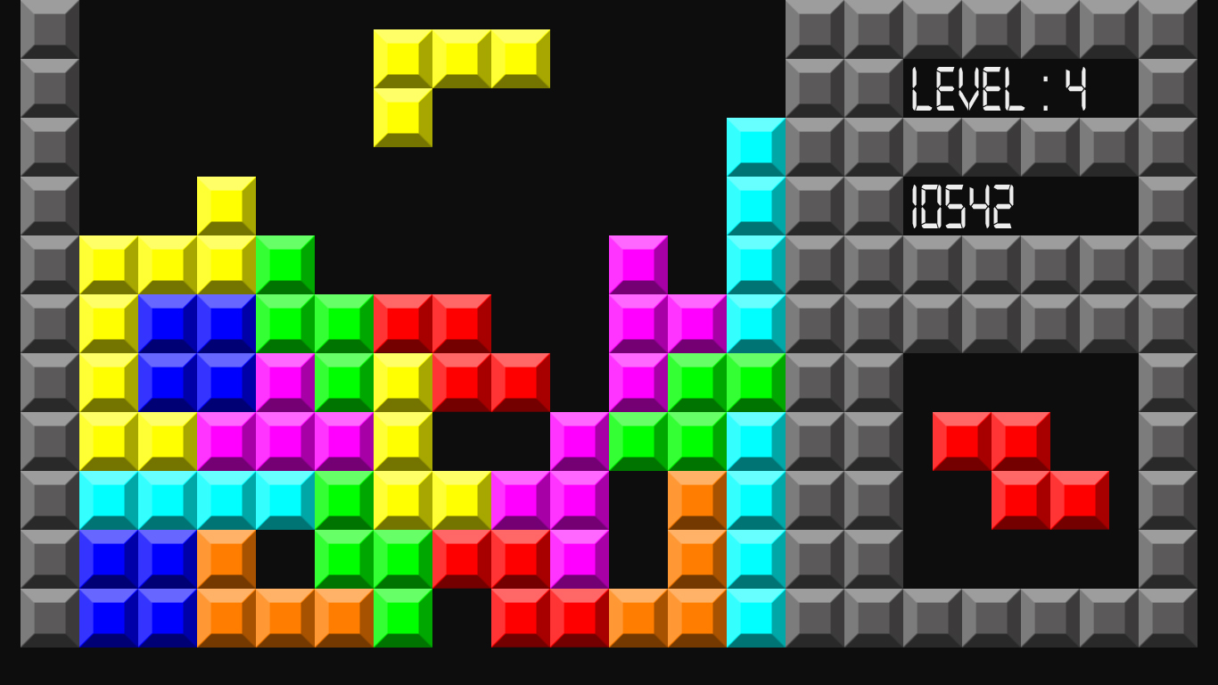

Home Alone – Movie

Release Date: November 1990

Production Company: Twentieth Century Fox

Genre: Comedy

Home Alone is a movie about a young boy that is accidentally left behind by his parents when they go on holiday. The boy then begins rigging traps around his house in an effort to thwart burglars from entering and robbing the house.

The traps the boy lays for the burglars in an effort to stop them is far more devious than what Cat Burglar attempts to re-create but it is still an obvious and important influence on the game.

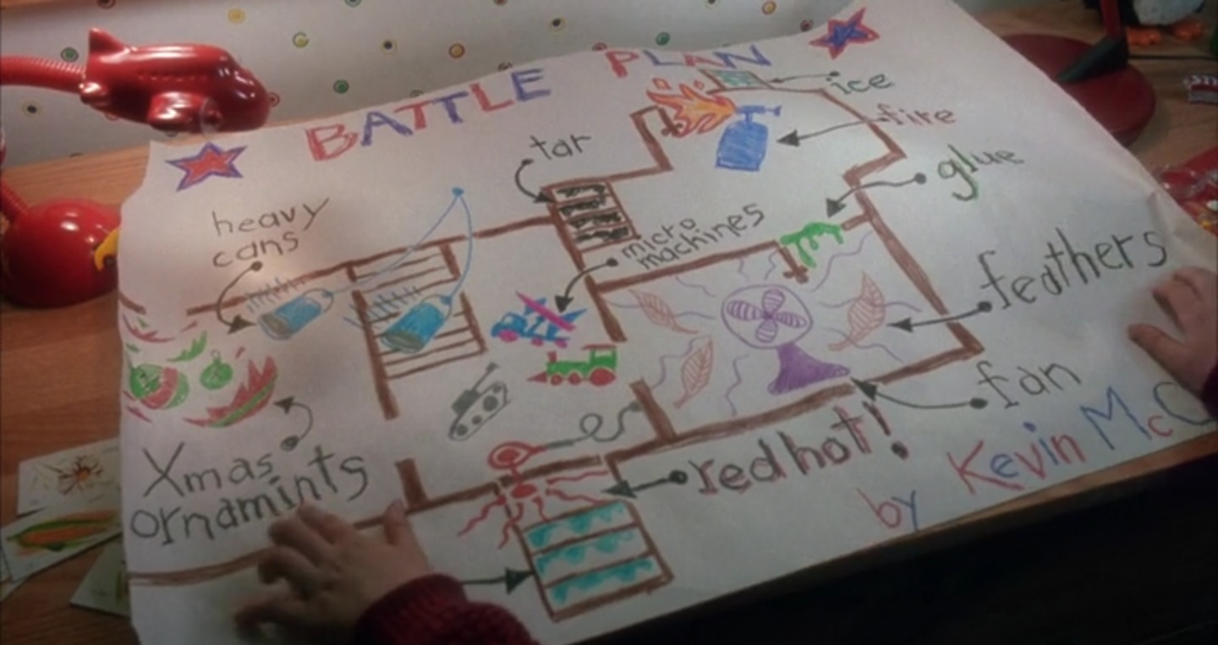

Die Hard – Movie

Release Date: July 1988

Production Company: Twentieth Century Fox

Genre: Action

Die Hard is a movie about an off-duty cop who gets unwittingly caught up in the attempted terrorist attack on an office block. The cop manages to elude capture by the terrorists when they initially take over the building, he then attempts to evade the terrorists as he tries to contact any emergency services in the vicinity in an effort to stop the terrorists and free the hostages.

Die Hard has a huge influence on Cat Burglar for two reasons, the first is the constant cat and mouse that is played out between the cop and the terrorists as the cop attempts to draw the attention of the emergency services to the situation, without giving away his position to the terrorists. The second is the way the cop uses any and all methods of subterfuge and distraction to move around the building and gain information about the terrorists.



**Target Market**

Cat Burglar will appeal to various audiences for different reasons depending on whether the person is interested in stealth or strategy games. The most common reason for people being interested in the game, will be because of ease of understanding the core elements of gameplay and its casual gameplay style, allowing for players to easily pick it up and start playing but an increasing difficulty will keep them playing over a discontinuous yet prolonged period of time.

These audiences will be broken up into three categories, Core, Secondary and Tertiary. Each audience will be attracted to the game for its short fun and strategic gameplay, how they first encounter the game is the main difference between the three groups.

The core target audience will be people who play either stealth or strategy games regularly and search for new games to play on a regular basis. We hope that these people will discover our game, and are excited and interested enough by the strategy of the game, that they then share it with friends to help increase awareness of our game.

The secondary audience will be the people who are directly shown the game and are interested in short, fun games that are easy to learn and don’t require a lot of involvement.

The tertiary audience will be people who are introduced to it over a sustained period of time by having a large enough group of people around them playing it, that they eventually decide to join in as it looks simple enough to learn and play.

**Personas**

Name: James Cartwright

Age: 18

Work: Student / Retail

Family: Lives with Parents and Siblings

Location: Sydney

Character: The Caregiver

Personality: ISFJ

Trait: Quiet, Humble, Reliable

Goals: To maintain a higher score than his brother

Constant practice to keep up his skill level

Always searching for new games to play

Frustrations: Brother is usually better at games

Brother has more time to play

Lack of money to purchase games

Bio: James is an example of the core target market, people who are always on the look-out for new games to play and are highly competitive.

James is likely to discover the game by either searching for new games on an online game platform or reading about it somewhere online.

Name: Monica Salisbury

Age: 43

Gender: Female

Work: Mortgage broker

Family: Married

Location: Seattle

Character: The Entertainer

Personality: ESFP

Trait: Energetic, Fun, Joker

Goals: To have fun, play the game and share with others

Doesn’t want to be too involved

Frustrations: Games that become tedious

Games that require a lot of time and effort to play

Bio: Monica is an example of the second category of the target market, people who like short, fun games that don’t require a lot of involvement.

Monica is most likely to get into the game after she has seen a friend playing it and if she thinks it looks like a fun challenge to pass the time.

Name: Phillip Gray

Age: 26

Gender: Male

Work: Mechanic

Family: Single

Location: London

Character: The Rebel

Personality: ISTP

Trait: Inventive, Bold, Adventurous

Goals: Plays to compete against friends and pass time

Good way to pass time when travelling or on break

Frustrations: Not very good at games due to other commitments

Not enough time to focus on being competitive

Bio: Phillip is an example of the third category of the target market, people who are exposed to it over a sustained period of time.

Phillip would be most likely to play the game only after several of his friends had already shown it to him, so he knows the basics of how to play and has a group of people he can compete and connect with about the game.

**SWOT Analysis**

|  |  |
| --- | --- |
| **Strengths** | **Weaknesses** |
| * Modular rooms for interchangeable level layout. * Programmer has made character controllers before. * Not a lot of complex mechanics that need programming. * Designer has made basic AI before and can help programmer. | * Programmer isn’t skilled at AI. * Could be a lot of assets required. * Designers first time in charge. * Team has not worked together before. |
| **Opportunities** | **Threats** |
| * Not many similar games on the market. * Innovative concept | * Over 7600 games released on steam in 2017 (approx. 20 per day). * Team has no marketing experience or budget. |

<https://www.polygon.com/2018/1/10/16873446/steam-release-dates-2017>

**Competitor Analysis**

Spy Mouse

Release date – August 2011

Developer – Firemint

Genre – Adventure

Strengths – simple gameplay, easy to learn, not a lot of mechanics involved.

Weaknesses – poor AI makes the game too easy.

Improvements – make the AI more difficult, while keeping simple gameplay mechanics.

Robbery Bob

Release date – May 2012

Developer – Level Eight

Genre – Adventure

Strengths – simple gameplay, more detailed and better graphics than spy mouse.

Weaknesses – very similar game to spy mouse with a different theme, useless items to collect with little in game value, poor AI.

Improvements – get rid of pointless collectables, improve AI.

The Masterplan

Release date: June 2015

Developer: Shark Punch

Genre: Strategy, Action

Strengths: in depth gameplay with many actions for the player to select and good use of strategy elements to vary the way you play levels, interesting well thought out narrative.

Weaknesses: confusing control system where the player controls more than one character simultaneously.

Improvements: reduce number of characters player can control at the same time.

Monaco

Release date: April 2013

Developer: Pocketwatch games

Genre: Stealth, Action

Strengths: multiple characters to play as, in depth gameplay and mechanics, great use of area of view mechanic, co-op gameplay.

Weaknesses: simple pixelated graphic characters and dark background makes it difficult to tell which character is which and what some of the game features are. Poor asset quality.

Improvements: increase quality of graphics especially characters to make the game more understandable and enjoyable to play.

**Gameplay Details**

**Core Gameplay Summary**

Cat Burglar is a stealth game with some minor puzzle or strategy elements in the way the player approaches how to most effectively move about the game without being caught while still trying to steal as many items as possible to gain the highest possible score.

**Goal**

To steal as many items as possible without alerting the residents and to escape the house before daylight.

**Objectives:**

* Steal items to increase score.
* Avoid making noise and alerting residents.
* Avoid traps in the house that will make noise and alert residents.
* Exit house before daylight (end of round/game).

**Conflict**

If the player makes too much noise within a close enough proximity of any of the residents, then the resident/s within range will be alerted to the players presence and will wake up and begin searching for the player, if the residents catch the player it will be game over and the player loses all items stolen.

**Mechanics**

Vital

* Movement – Player can move in 4 directions relative to the screen which will not move.
* Steal item – Player can grab/take item by pressing Ctrl button. Item will be removed from game and its value will be added to the players score.
* Glowing Item – Items player can collect will glow or have a sparkle to them, so it is obvious to the player what items they can steal.
* Score – Players score will increase as they steal items. Different items will have different values dependent on how hard the item is to steal.
* Noise detection area – A ring will appear around the player to indicate the area in which they can be detected by the resident/s (or dog) of the house. If the resident is inside this ring for an extended period of time, the resident will be alerted to the player and wake up and begin searching for the player.
* Resident / Enemy AI – If the player creates too much noise they will wake up the resident/s who will begin to search for the player and then chase them.
* Co-op – The addition of a second player working alongside the first.
* Daylight – The inclusion of daylight coming through the windows in the morning to indicate the player is about to run out of time.

Desired

* Hide – Player can hide in / under certain items of furniture if the resident has been alerted.
* Increased detection ring – As the player steals more items the detection ring will increase in size.
* Dog – If the dog is inside the players noise ring for an extended period of time, the dog will be alerted to the player and start barking creating a larger more sustained noise ring or alerting all residents of the house.
* Cutscene – At the start of the game a cutscene will show the schedule of the residents in the 24 hours prior to the player entering the house.

**Overview of Camera and Controls**

* The camera won’t have any controls and will be fixed in place as the game will all take place on a single screen.
* The character controls will all be relative to the screen, as follows:
  + Player 1
    - W = Walk UP
    - S = Walk Down
    - A = Walk Left
    - D = Walk Right
    - Left Ctrl = Pick up items
  + Player 2
    - ↑ = Walk Up
    - ↓ = Walk Down
    - ← = Walk Left
    - → = Walk Right
    - Right Ctrl = Pick up items

**Game Loops**

Core Loop

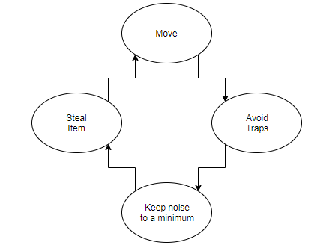

Gameplay Loop

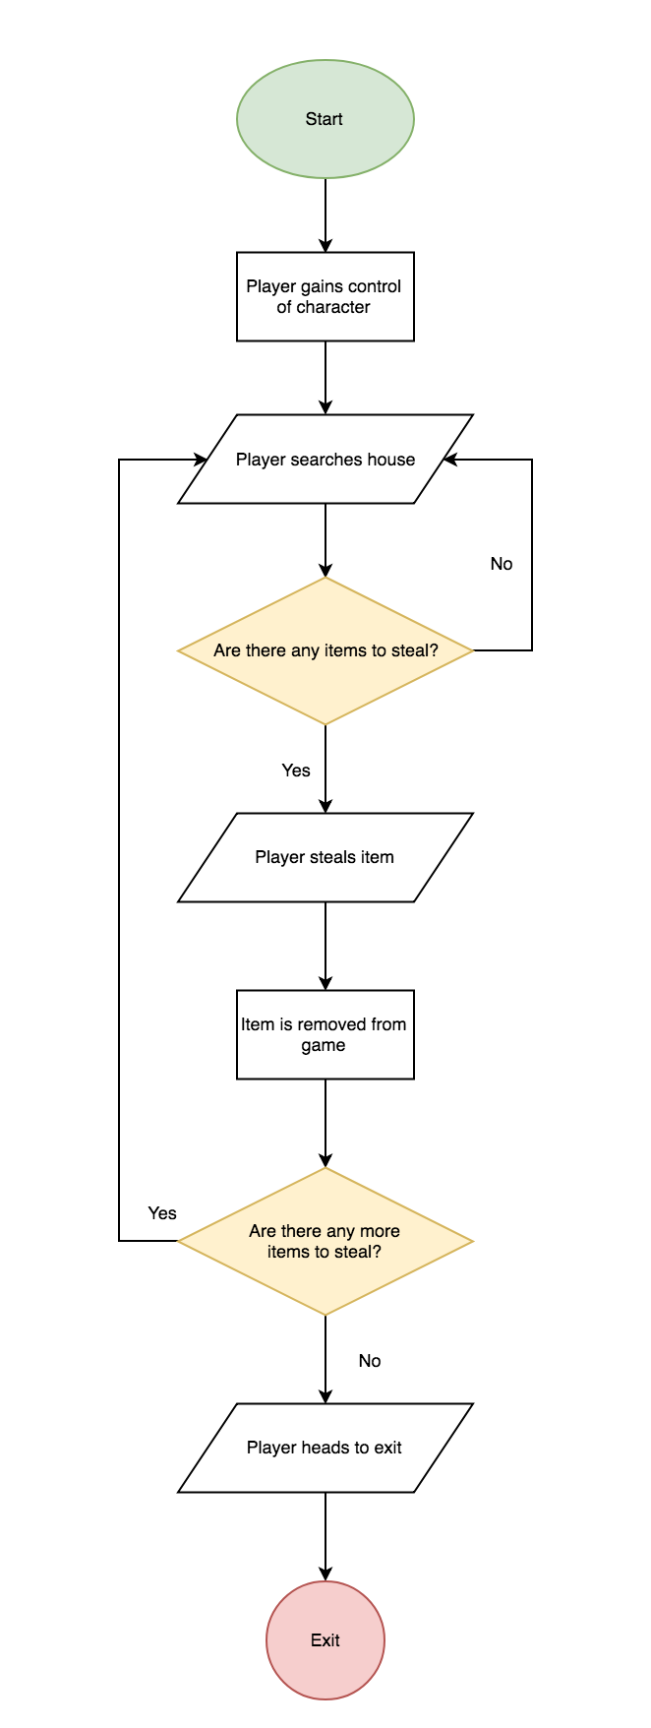

**Economy**

The economy in Cat Burglar can be broken down into a few core elements or resources, they are:

* Items that can be stolen
* Score increase based on value of item
* Character movement speed relative to noise generated
* Number of items carried by player increases noise generated
* Enemy AI dependent on noise being generated within close proximity
* Time limit

The player must steal items, this is the first major resource and can be broken down into two game elements, the tangible and physical aspect of the items the player collects in game and the value placed on the item which relates to the score and how much it will increase based on the value of the item.

The second major resource is the noise level generated by the player. The characters movement speed will increase the amount of noise the player makes. The higher the number of items the player is carrying the greater the noise level generated by the player. If the noise level generated by the player comes within a close enough proximity of the enemy AI, then the enemy will begin to chase the player until the player is caught or the player is able to evade the enemy.

The final major resource is the time limit which will dictate how long the game lasts and will be represented by the increased level of light coming in through the windows in game as an indication to the player that the sun is rising and they are running out of time.

**Content Plans**

**Levels**

Cat Burglar will be developed using interchangeable room assets, that represent the floorplan of a house, so that it will be possible to rearrange the layout of the house to change the difficulty. During production we will only use a single floorplan layout until we have established all other mechanics are working.

**Enemies**

The main enemies in our game will be the residents of the house, who will be asleep at the start of the game and only wake up if they are alerted to the players presence if they make too much noise.

**Items to Steal**

* Rolex watch 1000 points
* Diamond ring 500 points
* Smart phone 500 points
* Pearl necklace 400 points
* Television 300 points
* Game console 200 points
* DVD player 100 points
* Coffee machine 100 points
* Hair dryer 10 points
* Toaster 10 points
* Blender 10 points
* DVD 10 points
* Video game 10 points

**Rooms**

* Bedroom 1
* Kitchen
* Lounge room
* Bathroom
* Bedroom 2
* Laundry
* Office
* Garage

**Items (other)**

* Dog (with basket or mat)
* Door
* Double bed
* Single bed
* Bedside drawers
* Wardrobe
* Cupboard (kitchen)
* Kitchen sink
* Table
* Chair
* Lounge
* Coffee table
* Bookshelf
* Lamp
* Bath
* Toilet
* Hand basin

**Unlocks/Awards**

* Silent Intruder
* Hasty Thief

**Visual FX**

* Sound detection radius circle around player
* Sunlight coming through windows in morning
* Dog barking noise ring (or similar effect to simulate dog bark)

**Sound FX**

* Dog barking
* ‘Clink’ when player steals item

**Schedule**

**Art Assets**

|  |  |
| --- | --- |
| Player Character Model | Due Date |
| Concept sketches  Character model  Textured model  Rigged model  Animated | 12/10/18  19/10/18  26/10/18  2/11/18  9/11/18 |

|  |  |
| --- | --- |
| Enemy Character Model | Due Date |
| Concept sketches  Character model  Textured model  Rigged model  Animated | 12/10/18  19/10/18  26/10/18  2/11/18  9/11/18 |

|  |  |
| --- | --- |
| Dog Character Model | Due Date |
| Concept sketches  Character model  Textured model  Rigged model  Animated | 12/10/18  19/10/18  26/10/18  2/11/18  9/11/18 |

|  |  |
| --- | --- |
| Item to Steal Assets | Due Date |
| Rolex watch  Diamond ring  Smart phone  Pearl necklace  Television  Game console  DVD player  Coffee machine  Hair dryer  Toaster  Blender  DVD  Video game | 16/11/18  16/11/18  16/11/18  16/11/18  16/11/18  16/11/18  16/11/18  16/11/18  16/11/18  16/11/18  16/11/18  16/11/18  16/11/18 |

|  |  |
| --- | --- |
| Environment Assets | Due Date |
| Interior walls  Exterior walls  Door  Double bed  Single bed  Bedside drawers  Wardrobe  Cupboard (kitchen)  Kitchen sink  Table  Chair  Lounge  Coffee table  Bookshelf  Lamp  Bath  Toilet  Hand basin  UI | 9/11/18  9/11/18  9/11/18  16/11/18  16/11/18  16/11/18  16/11/18  16/11/18  16/11/18  16/11/18  16/11/18  16/11/18  16/11/18  16/11/18  16/11/18  16/11/18  16/11/18  16/11/18  16/11/18 |

**Programming**

|  |  |
| --- | --- |
| Function | Due Date |
| Character controller  Pick up item  Score  Noise detection ring  Enemy AI  Dog AI  Co-op  Menu  UI  Timer (Daylight)  Cutscene  Hide | 26/10/18  2/11/18  2/11/18  9/11/18  9/11/18  9/11/18  9/11/18  16/11/18  16/11/18  16/11/18  23/11/18  23/11/18 |